8th PL ELA
Syllabus
Ms. Farrell
megan.farrell@k12.sd.us
meganfa@harrisburg.k12.sd.us

What you will need:
- A binder (1” to 1 ½” is fine.) OR a folder
- Either a stack of loose-leaf paper or a notebook (without fringe)
- A pencil
- A highlighter
- Earbuds

Policies and Procedures

Grading Policy
Harrisburg South Middle School (HSMS) uses a standards-based grading system, meaning each assignment is attached to a standard. The grading scale is shown below:
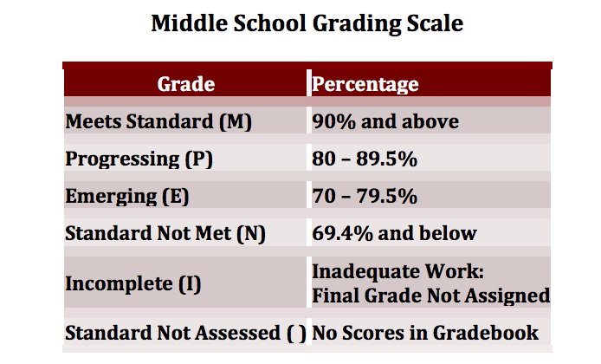

You can access your student’s grades at parent portal: https://sis2.ddncampus.net/campus/portal/harrisburg.jsp.

Make Up Work
Students have two days for each day absent to make up work assigned while they were gone. For example: three days missed = six school days to make up work.
If you are absent the day something is DUE, the assignment is due the DAY YOU RETURN TO SCHOOL.

Late Work/Unacceptable Work
Students with missing assignments and/or who turn in work that does not meet the standard assessed will be immediately referred to ICU. When I grade assignments, I enter them into the ICU database.

Students missing work may be assigned Directed Studies during the day or Power Hour, which occurs before school from 7:30 – 8:00 and after school from 3:05 – 4:00. Additionally, students may be assigned Saturday School for one of the following reasons:
- Three or more incomplete or late assignments
- One or more incomplete assignments one week past the due date(s)
- A project that requires more time to complete

Tardiness
Students will be considered tardy for class if they are not present when class begins. Students will receive a pink slip if they are not prepared for class with the appropriate materials when the bell rings.

I am a well.
…and like a well, I only have so much energy before I begin to feel drained. Please help me out by not bombarding me with requests the moment you walk in the door. As young adults, I expect you to arrange to meet with me before or after school, especially if you need to talk with me at length. This is especially true for students looking for make-up work. If you have a quick question, stop in for a chat. I cannot start a lesson if I am trying to answer multiple questions from students.

Consequences
For minor issues in the classroom, students will receive a pink slip, which serves as a warning to the student. Contact with the student’s parent is made to inform them of the issue. A student can receive up to five pink slips per quarter. After the fifth pink slip is issued, students will be automatically sent to the office for any classroom issues.

For major issues in the classroom, students will be sent to the office and receive a behavior referral. At that point, the administration will decide the appropriate consequence for the student’s actions.

